Project Planning Phase
Project Planning Template (Product Backlog, Sprint Planning, Stories, Story points)

Date | 15 February 2025
Team ID | LTVIP2026TMIDS71321
Project Name | Dog Breed Identification Using Transfer Learning
Maximum Marks | 5 Marks

Product Backlog, Sprint Schedule, and Estimation (4 Marks)
Use the below template to create product backlog and sprint schedule
Sprint | Functional Requirement (Epic) | User Story Number | User Story / Task | Story Points | Priority | Team Members
Sprint-1 | Dataset preparation | USN-1 | Collect dog breed images data set from Kaggle | 3 | High | 1
Sprint-1 | Dataset preparation | USN-2 | Organize images into train and test folders | 2 | High | 2
Sprint-1 | Dataset preparation | USN-3 | Perform image preprocessing(resize ,normalize) | 3 | High | 2
Sprint-2 | Model building | USN-4 | Implement transfer learning using VGG19 | 5 | High | 3
Sprint-2 | Model building | USN-5 | Train the CNN model on dataset | 4 | High | 3
Sprint-2 | Model building | USN-6 | Evaluate model accuracy and loss | 2 | Medium | 2
Sprint-3 | Web Application | USN-7 | Upload dog image through web interface | 3 | High | 1
Sprint-3 | Web Application | USN-8 | Predict dog breed using trained model | 4 | High | 1
Sprint-3 | Web Application | USN-9 | Display predicted breed | 2 | High | 2
Sprint-4 | Testing & Deployment | USN-10 | Test application with various images | 3 | High | 3
Sprint-4 | Testing & Deployment | USN-11 | Fix errors and optimize performance | 2 | Medium | 3
Sprint-4 | Testing & Deployment | USN-12 | Deploy application using Flask | 3 | High | 2

Project Tracker, Velocity & Burndown Chart: (4 Marks)
Sprint | Total Story Points | Duration | Sprint Start Date | Sprint End Date (Planned) | Story Points Completed (as on Planned End Date) | Sprint Release Date (Actual)
Sprint-1 | 20 | 6 Days | 26 Jan 2026 | 01 Feb 2026 | 20 | 01 Feb 2026
Sprint-2 | 20 | 6 Days | 01 Feb 2026 | 07 Feb 2026 | 20 | 07 Feb 2026
Sprint-3 | 20 | 6 Days | 07 Feb 2026 | 13 Feb 2026 | 20 | 13 Feb 2026
Sprint-4 | 20 | 6 Days | 13 Feb 2026 | 19 Feb 2026 | 20 | 19 Feb 2026

Velocity:
Imagine we have a 10-day sprint duration, and the velocity of the team is 20 (points per sprint). Let’s calculate the team’s average velocity (AV) per iteration unit (story points per day)
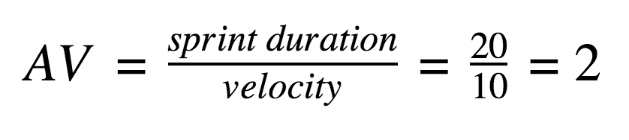
Burndown Chart: Burn down charts can be applied to any project containing measurable progress over time. The burndown chart represents the progress of the Dog Breed Identification project across four sprints. Initially, the project had 80 story points. After each sprint, 20 story points were completed, reducing the remaining work to zero by the end of Sprint-4. This shows that the team completed the project on schedule.
